

press release no. 3
(English translation)

BOOK&GO, FEMALE TRAVEL AND AFRICA ON THE RISE

- Two new special sections in the narrative workshop of TTG Travel Experience in which writers, videomakers and photographers offer new stimuli to tourism professionals, from informative techniques to travel inspiration

- The Italian Exhibition Group trade fair runs at Rimini Expo Centre from 9 to 11 October, parallel with InOut|The Contract Community

www.ttgexpo.it

Rimini, 1-9 October 2024 – Book&Go (www.ttgexpo.it/eventi/book-go) is back at the 61st edition of TTG Travel Experience by Italian Exhibition Group (from 9 to 11 October at Rimini Expo Centre). This narrative workshop features writers, videomakers and photographers explaining how to create effective narrative and promotional tools. A space assigned to creativity, with open and direct discussions between tourism operators and expert storytellers. On the stage of the Book&Go Arena (Piscine Ovest A2/C2) alternating travel stories will be narrated through video, with voiceovers of prominent figures from the world of travel culture. The new features of this edition of Book&Go highlight two special sections: the first dedicated to female travel, with stories told by travellers and travel bloggers who are a source of inspiration for solo travellers who want to travel the world safely. The second, dedicated to Africa, will guide the public in the discovery of a continent that is definitely moving with the times. Speakers on the topic include a journalist, a photojournalist and a solo traveller.

FROM HOT TOURISM TOPICS TO TRAVEL STORYTELLING, INTROSPECTIVE ADVENTURES AND THE COURAGE TO DREAM
Book&Go kicks off with travel stories on social media, with Denis Falconieri, author of Lonely Planet Italia and Pietro Contaldo, president of Igersitalia who will provide food for thought on the multiple forms of narration of a travel destination starting from guidebooks, in the conference “Lonely Planet and the story of a destination: from guides to social media”.
Current critical issues related to tourism such as Overtourism will also be addressed by travel blogger Monica Cesarato, who will explain to the public how to find the value of destinations less frequented by mass tourism. Beautiful stories of destinations will be described by the journalist Alberta Voltolini, thrilling the public with "The power of words. People to tell, stories to free". The eagerly anticipated writer Gianluca Gotto will lead the conference entitled “When happiness begins. If our best time is today”, inspired by his book, a journey through the author's personal growth path with ideas for living your life to the fullest, starting from universal questions. Content creator Francesco Morelli will inspire the public with #Neverstopdreaming, an intimate story, which begins with an unhappy childhood and passes through a life of sacrifice, until the courage to change sets in. Sara Furlanetto and Yuri Basilicò, authors of the book, "Va' sentiero. In cammino per le Terre Alte d'Italia”, will describe their mountain explorations by way of a project that has received numerous awards, including the Grand Prix at the Europa Nostra Awards 2022. Adventurous stories will also be discussed in “Overland, a lifelong adventure. Story of a lover of people and mountains” by Beppe Tenti, who has been on extraordinary explorations all over the world, from the Himalayas to the Silk Road, from Northern Europe to North America, from Patagonia to Kilimanjaro. On the Book&Go stage, space will be given to introspective and spiritual journeys in the talks “We are what we can become” by populariser Oscar Di Montigny, and “Leaving is like healing. Immigration as therapeutic path” by activist Stefano Rolfo.
Crucial issues such as women's rights and LGBTQIA+ communities will be addressed in "Other places, other sexual customs. 86 countries in the mirror, their rights and prohibitions" by journalist Pietro Tarallo who has travelled through 86 countries to discover places still under repression. Alberto Abbà will turn the spotlight on places that have experienced the tragedy of earthquakes: "Spotlight on the Muted Lands. Where the flowers of rebirth bloom" is a journey through the countries that are slowly getting back on their feet, also working to create a new hospitality economy.
The lure of the East will be the focus of the talk by Sunny Terranova, creator of the very popular IG page "Giapponizzati". In "Unexpected glimpses of the Land of the Rising Sun" the author invites us to look at Japan with new eyes, avoiding tourist itineraries and the most inflated information. Nature and water will be the main themes of the appointment with the travel writer Winki, “Discovering the Water Planet”, a travel story to the most enchanting places of the Water Planet explored by the author on a surfboard.
An exciting and creative comparison between videomakers will conclude the last day of Book&Go with “Action, we’re off. Ideas for narrating on the move” curated by Emanuele Valpondi and Marco Epifani.

FEMALE TRAVEL AND DISCOVERING AFRICA
The world of tourism is witnessing an interesting all-female trend, which could help boost the industry: 71% of bookings for ‘solo-travel’ are organised specifically for women travellers. At Book&Go this year a special section is dedicated to women. From their personal experiences described in their books, Ilaria Bonfante, Marta Pellegrini and Anna Pernice will debunk the clichés linked to solo-travellers in the panel “I travel alone. How to transform yourself into globetrotting women”. The last day of Book&Go will be dedicated to the discovery of the fascinating African continent, another new feature of the event. “Africa in vogue. The redemption of a continent”, a journey through haute couture, architecture, lights, environments to take a deep dive into the Africa of 2024 with Francesca Spinola, Alessandro Barbisan and Graziano Villa.

ABOUT: TTG TRAVEL EXPERIENCE
Event: international trade show; organizer: Italian Exhibition Group SpA; recurrence: annual; edition: 61st; open to: reserved exclusively for trade professionals; website: www.ttgexpo.it - #ttgexpo

ABOUT: INOUT | THE CONTRACT COMMUNITY
Event: international trade show; organizer: Italian Exhibition Group SpA; recurrence: annual; edition: 2nd edition of INOUT including SIA, SUN, SUPERFACES, GREENSCAPE; open to: reserved exclusively for trade professionals; website: www.inoutexpo.it #inoutexpo

PRESS CONTACT IEG, TTG TRAVEL EXPERIENCE
Elisabetta Vitali, head of corporate communication & media relation; Marco Forcellini, Pier Francesco Bellini, press office manager - media@iegexpo.it

MEDIA AGENCY TTG TRAVEL EXPERIENCE: Mind The Pop
Martina Vacca: martina@mindthepop.it, mob. +39 339 748 4994; Fabrizio Raimondi: fabrizio@mindthepop.it, mob. +39 335 389 848; Benedetto Colli: benedetto@mindthepop.it, mob. 380 371 2272; Stefano Chiossi: stefano@mindthepop.it, mob. + 39 388 739 4358.

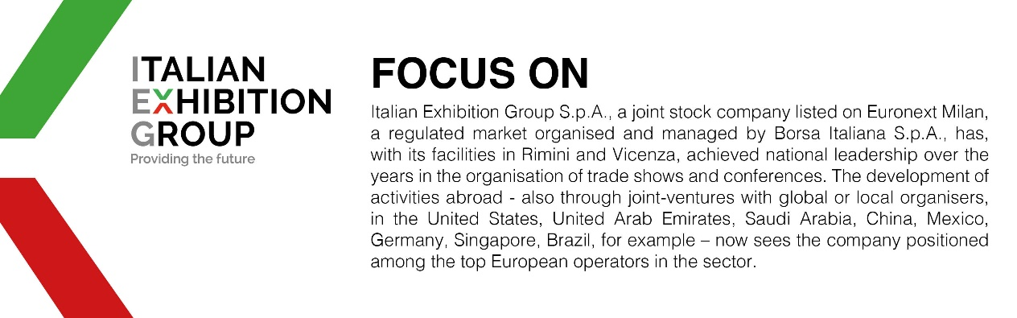

This press release contains forecast elements and estimates that reflect the management’s current opinions (“forward-looking statements”), particularly regarding future management performance, realization of investments, cash flow trends and the evolution of the financial structure. For their very nature, forward-looking statements have a component of risk and uncertainty, as they depend on the occurrence of future events. The effective results may differ (even significantly) from those announced, due to numerous factors, including, only by way of example: food service market and tourist flow trends in Italy, gold and jewellery market trends, green economy market trends; the evolution of raw material prices; general macroeconomic conditions; geopolitical factors and evolutions in the legislative framework. Moreover, the information contained in this release does not claim to be complete, and has not been verified by independent third parties. Forecasts, estimates and objectives contained herein are based on the information available to the Company as at the date of this release.

